**NAME: Parth N Patel**

**ID: 19DCS098**

**SUBJECT: Database Management System**

**SUBJECT CODE: CE246**

**SEM: 4**

**PRACTICAL-1**

**Evaluation of Database (File System, DBMS, RDBMS, DDBMS)**

**File System**

* A file processing system(fps) is a technique of arranging the files in a storage medium like a hard disk, pen drive, DVD, etc. It helps you to organizes the data and allows easy retrieval of files when they are required. It mostly consists of different types of files like mp3, mp4, txt, doc, etc. that are grouped into directories.
* A file system enables you to handle the way of reading and writing data to the storage medium. It is directly installed into the computer with the Operating systems such as Windows and Linux.

**Example:**

NTFS (New Technology File System), EXT (Extended File System).

## Features of a File system:

* It helps you to store data in a group of files.
* Files data are dependent on each other.
* C/C++ and COBOL languages were used to design the files.
* Shared File System Support
* Fast File System Recovery.

**Advantages of File system:**

* Enforcement of development and maintenance standards.
* Helps you to reduce redundancy
* Avoid inconsistency across file maintenance to get the integrity of data independence.
* Firm theoretical foundation (for the relational model).
* It is more efficient and cost less than a DBMS in certain situations.
* The design of file processing is simpler than designing Database.

**Disadvantages of File Processing system:**

* Each application has its data file so, the same data may have to be recorded and stored many times.
* Data dependence in the file processing system are data-dependent, but, the problem is incompatible with file format.
* The problem with security.
* Time-consuming.
* It allows you to maintain the record of the big firm having a large number of items.
* Required lots of labour work to do.

**Application of File system:**

* Language-specific run-time libraries
* API programs using it to make requests of the file system
* It is used for data transfer and positioning.
* Helps you to update the metadata
* Managing directories.

**DBMS (Database Management System):** 

* Database Management System is basically a software that manages the collection of related data. It is used for storing data and retrieving the data effectively when it is needed. It also provides proper security measures for protecting the data from unauthorized access. In Database Management System the data can be fetched by SQL queries and relational algebra. It also provides mechanisms for data recovery and data backup.

**Example:**

Oracle, MySQL, MS SQL server.

**Features of DBMS:**

* A user-accessible catalog of data
* Transaction support
* Concurrency control with Recovery services
* Authorization services
* The value of data is the same at all places.
* Offers support for data communication
* Independent utility services
* Allows multiple users to share a file at the same time

**Advantages of DBMS:**

* DBMS offers a variety of techniques to store & retrieve data
* Uniform administration procedures for data
* Application programmers never exposed to details of data representation and Storage.
* A DBMS uses various powerful functions to store and retrieve data efficiently.
* Offers Data Integrity and Security
* Reduced Application Development Time
* Consume lesser space
* Reduction of redundancy.
* Data independence.

**Disadvantages of the DBMS:**

* Cost of Hardware and Software of a DBMS is quite high, which increases the budget of your organization.
* Most database management systems are often complex systems, so the training for users to use the DBMS is required.
* Data-sets begins to grow large as it provides a more predictable query response time.
* It required a processor with the high speed of data processing.
* The database can fail because or power failure or the whole system stops.

**Application of the DBMS:**

* Admission System Examination System Library System
* Payroll & Personnel Management System
* Accounting System Hotel Reservation System Airline Reservation System
* DBMS system also used by universities to keep call records, monthly bills, maintaining balances, etc.
* Finance for storing information about stock, sales, and purchases of financial instruments like stocks and bonds.

**KEY DIFFERENCES BETWEEN FPS & DBMS:**

* A file system is a software that manages and organizes the files in a storage medium, whereas DBMS is a software application that is used for accessing, creating, and managing databases.
* The file system doesn't have a crash recovery mechanism on the other hand, DBMS provides a crash recovery mechanism.
* Data inconsistency is higher in the file system. On the contrary Data inconsistency is low in a database management system.
* File system does not offer concurrency, whereas DBMS provides a concurrency facility.

**RDBMS (Relational Database Management System):**

* A relational database management system (RDBMS) is a program that allows you to create, update, and administer a relational database. Most relational database management systems use the SQL language to access the database.
* RDMBS adds the R of relational to the existing Database management technology. Created in the 1970s, RDBMS was designed to be a more sophisticated version of DBMS. RDBMS also adds a degree of finesse for the organization or the individuals accessing the data stored in the database.
* One key feature of RDBMS is that it can only keep the tabular form of data. Data in RDBMS is stored and sorted in the form of rows, columns (also called tuples and attribute in the DBMS language).

**Example:**

MySQL, PostgreSQL, Db2

**Features of RDBMS:**

* All data stored in the tables are provided by an RDBMS
* Ensures that all data stored are in the form of rows and columns
* Facilitates primary key, which helps in unique identification of the rows
* Facilitates a common column to be shared amid two or more tables
* Multi-user accessibility is facilitated to be controlled by individual users.

**Advantages of RDBMS**:

* It is secured in nature.
* The data manipulation can be done.
* It limits redundancy and replication of the data.
* It offers better data integrity.
* It provides better physical data independence.

**Disadvantages of RDBMS**:

* Software is expensive.
* It requires skilled human resources to implement.
* It is difficult to recover the lost data.
* Complex software refers to expensive hardware and hence increases overall cost to avail the RDBMS service.

**DDBMS (Distributed Database Management System):**

* Distributed Database Management System (DDBMS) is a type of DBMS which manages a number of databases hoisted at diversified locations and interconnected through a computer network. It provides mechanisms so that the distribution remains oblivious to the users, who perceive the database as a single database.

**Features of DDBMS:**

* It is used to create, retrieve, update and delete distributed databases.
* It synchronizes the database periodically and provides access mechanisms by the virtue of which the distribution becomes transparent to the users.
* It is used in application areas where large volumes of data are processed and accessed by numerous users simultaneously.
* It is designed for heterogeneous database platforms.
* It maintains confidentiality and data integrity of the databases.

**Advantages of DDBMS**:

* Reflects organizational structure
* Improved share ability
* Improved availability
* Improved reliability
* Improved performance

**Disadvantages of DDBMS**:

* Increased Cost
* Integrity control more difficult,
* Lack of standards,
* Database design more complex.
* Complexity of management and control. Applications must recognize data location and they must be able to stitch together data from various sites.

**PRACTICAL-3**

**AIM: To study DDL-create and DML-insert commands.**

QUERIES:

* Describe deposit, branch.

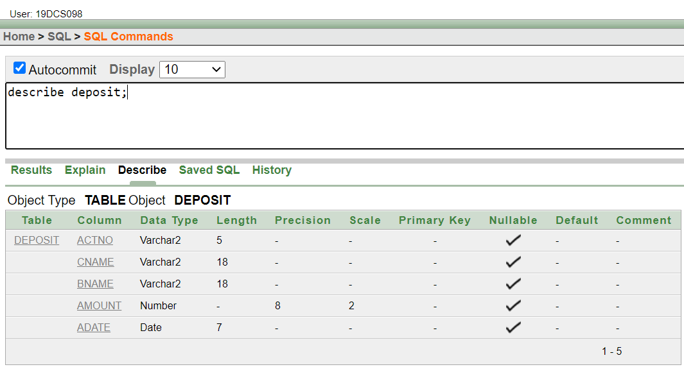

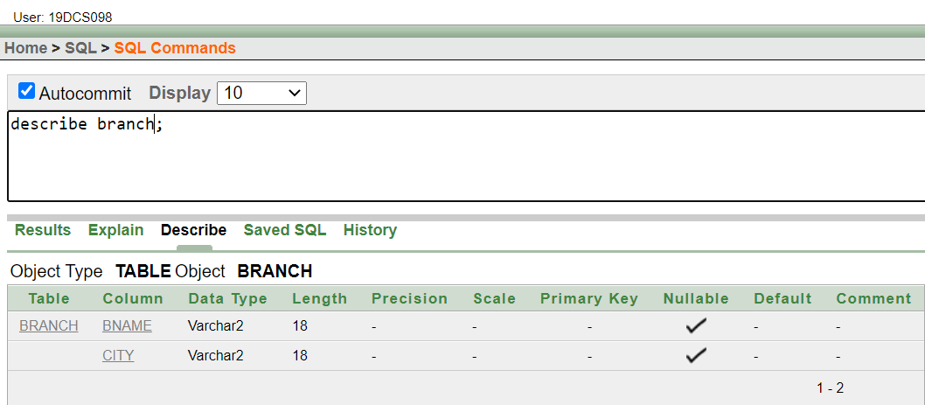

* Describe borrow, customers.

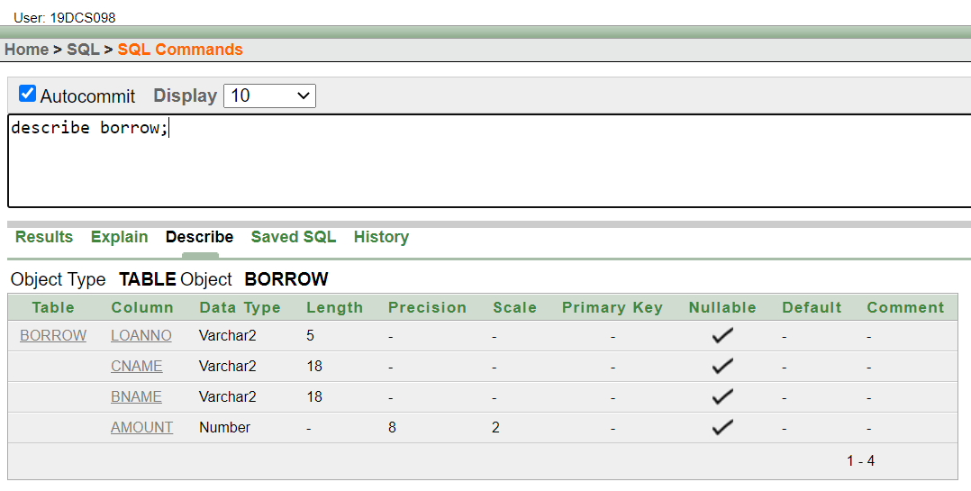

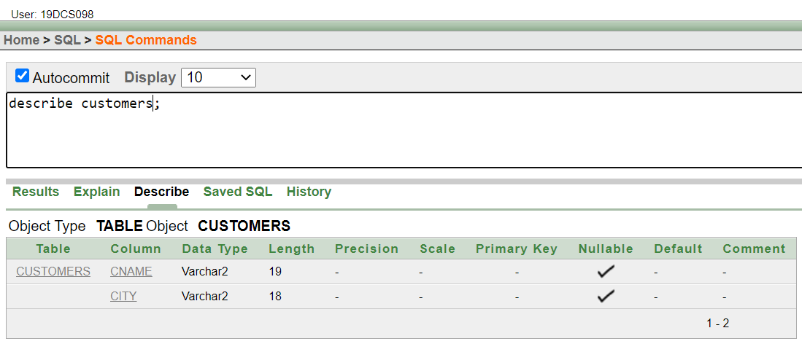

* List all data from table DEPOSIT

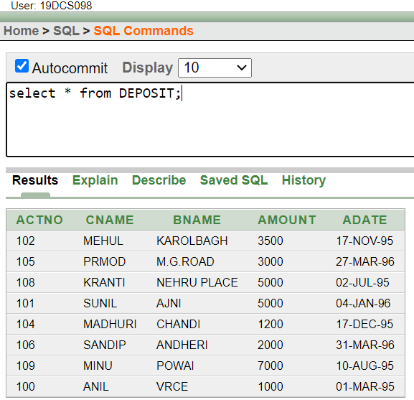

* List all data from table BORROW.

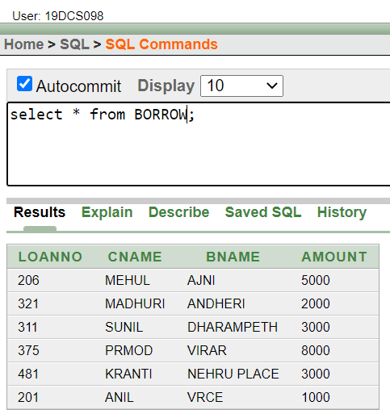

* List all data from table CUSTOMERS.

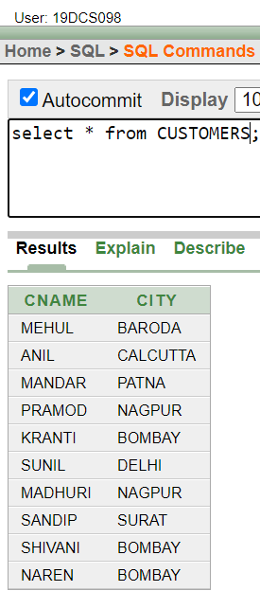

* List all data from table BRANCH.

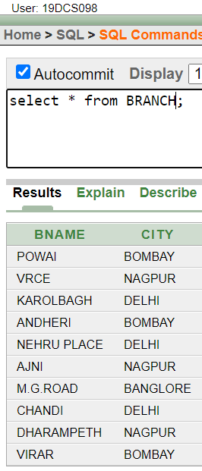

* Give account no and amount of depositors.

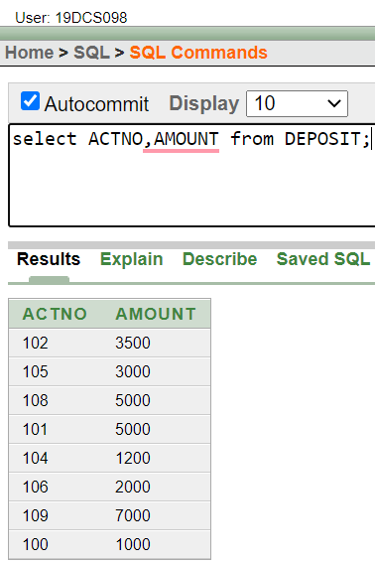

* Give name of depositors having amount greater than 4000.

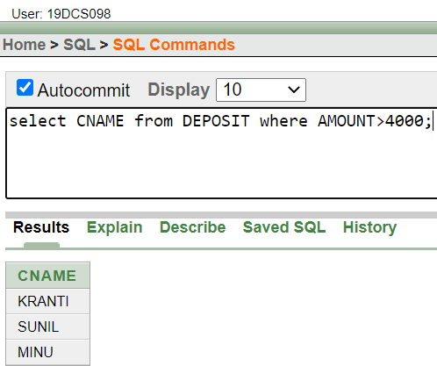

* Give name of customers who opened account after date '1-12-96'.

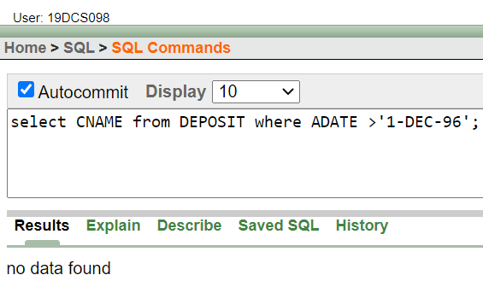

* Give name of city where branch karolbagh is located.

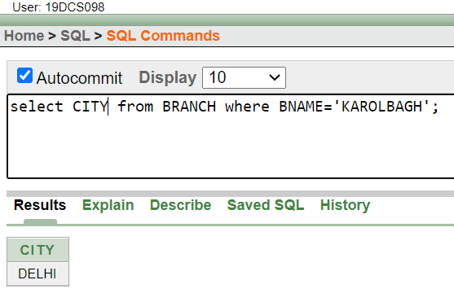

* Give names of depositors having account at VRCE

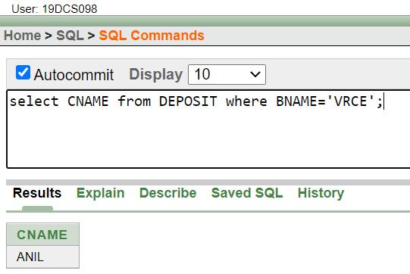

**PRACTICAL-4**

**AIM: Perform following queries**

QUERIES:

* Retrieve all data from employee, jobs and deposit.

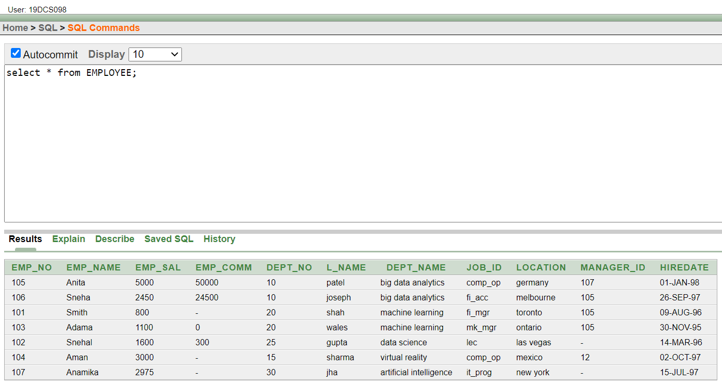

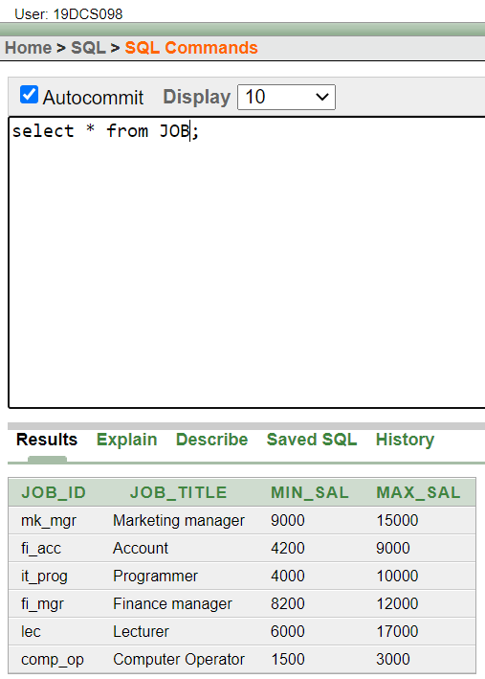

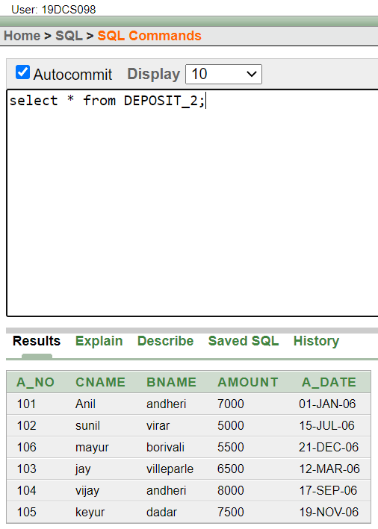

* Give details of account no. and deposited rupees of customers having account opened between dates 01-01-06 and 25-07-06

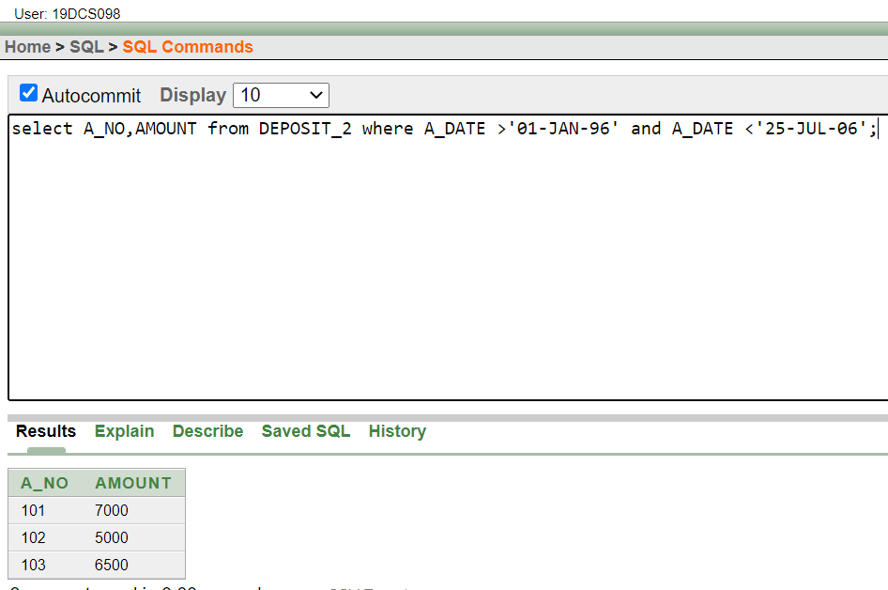

* Display all jobs with minimum salary is greater than 4000.

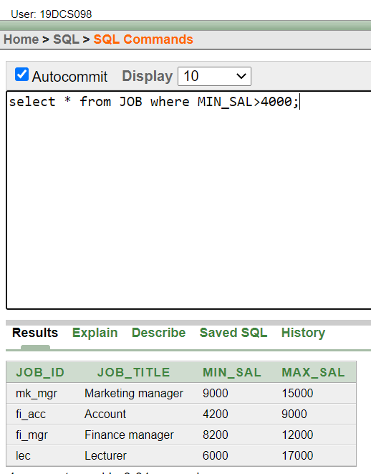

* Display name and salary of employee whose department no is 20. Give alias name to name of employee.

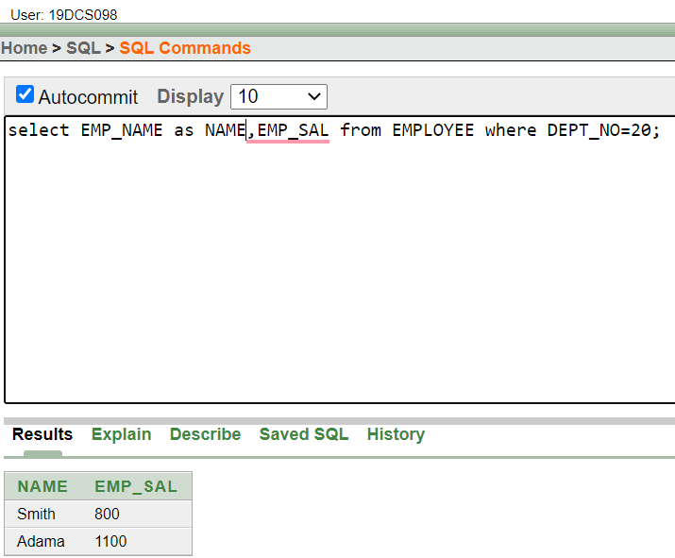

* Display employee no, name and department details of those employee whose department lies in (10,20).

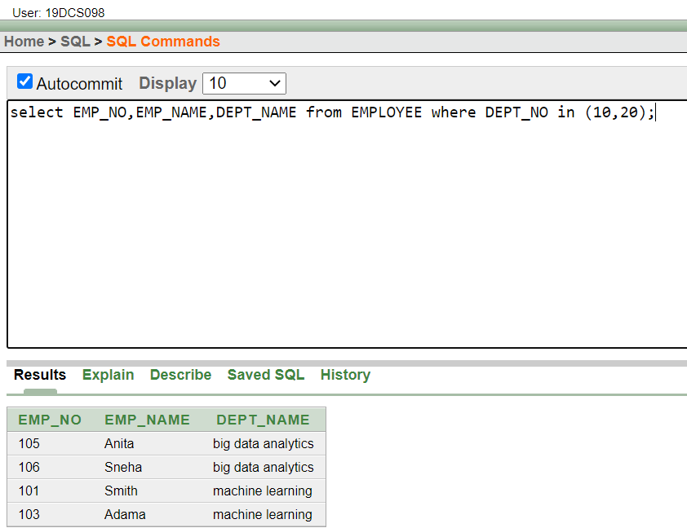

* Display the non-null values of employees.

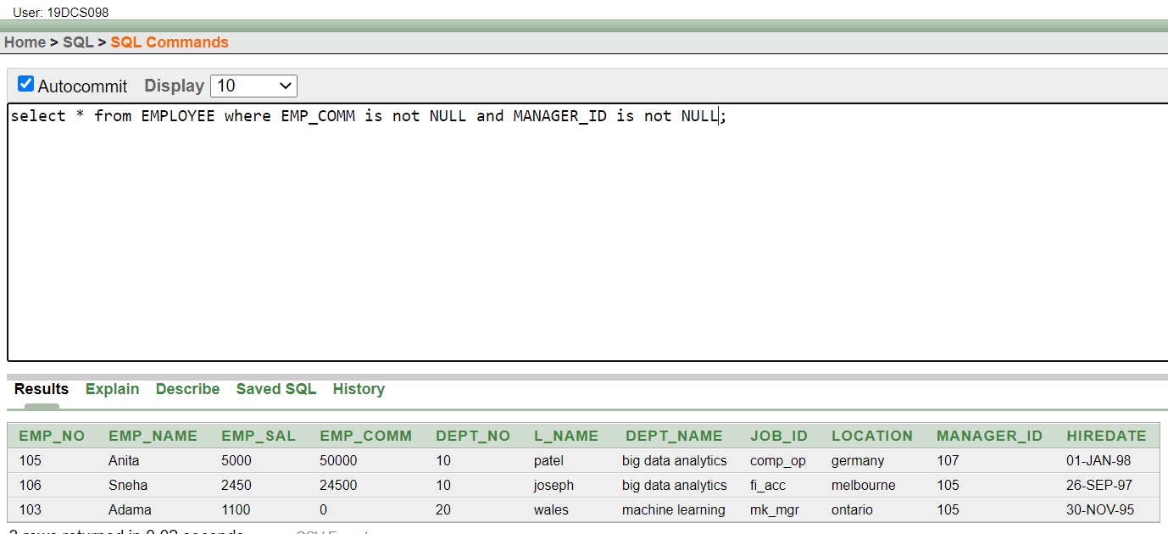

* Display name of customer along with its account no (both column should be displayed as one) whose amount is not equal to 8000 Rs.

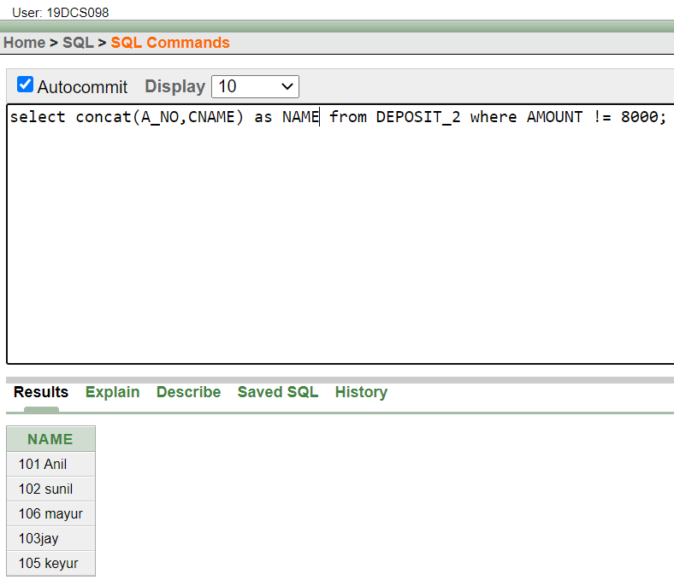

* Display the content of job details with minimum salary either 2000 or 4000.

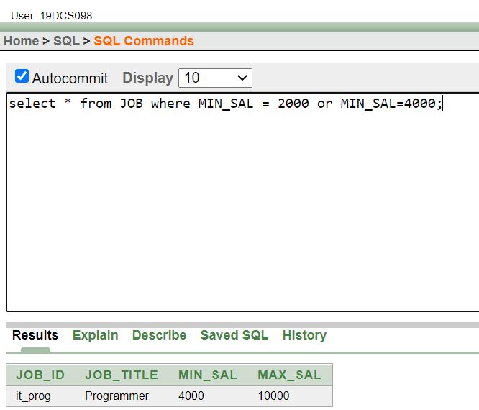

To study various options of LIKE predicate

* Display all employee whose name start with ‘A’ and third character is ‘‘a’

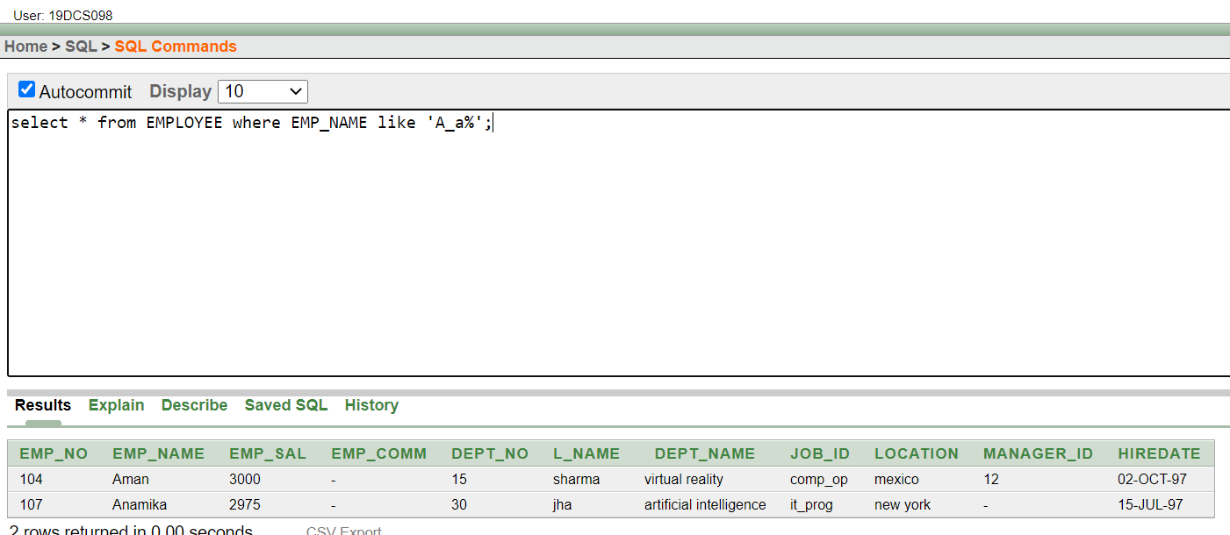

* Display name, number and salary of those employees whose name is 5 characters long and first three characters are ‘Ani’.

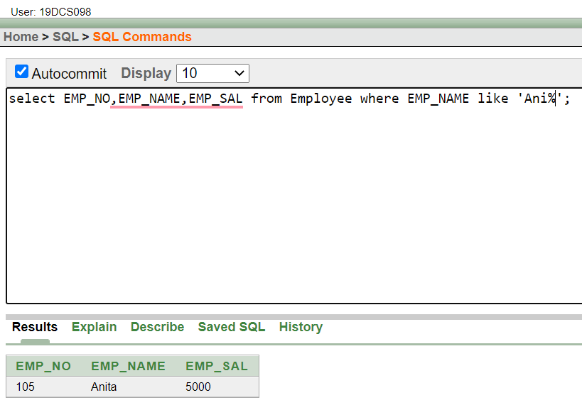

* Display the job name whose first three character in job id field is ‘FI_’.

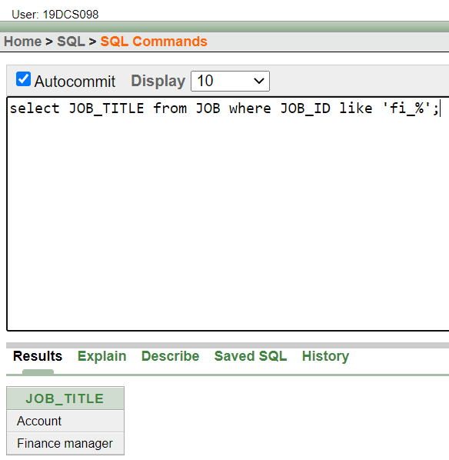

* Display the title/name of job who’s last three character are ‘_MGR’ and their maximum salary is greater than Rs 12000.

